ISSUE – SPECIFICATION-OVERVIEW

Nanthakumar JJ12:14 PM

**SELECT** **distinct** template_description, template_plant, PART_PLANT

**FROM**  sc_lims_dal.av_spec_overview_plant_frame_id *a*

**WHERE** *a*.part_plant = (**'GYO'**)

**and**   *a*.frame_id   = (**'A_Bead v1'**)

**UNION**

**SELECT** **'No template'**, **null**, **null**

**order** **by** 1

;

  image   by Nanthakumar JJNanthakumar JJ12:15 PM

Nanthakumar JJ12:14 PM

**SELECT** **distinct** template_description, template_plant, PART_PLANT

**FROM**  sc_lims_dal.av_spec_overview_plant_frame_id *a*

**WHERE** *a*.part_plant = (**'GYO'**)

**and**   *a*.frame_id   = (**'A_Bead v1'**)

**UNION**

**SELECT** **'No template'**, **null**, **null**

**order** **by** 1

;

with props

has context menu

ONLY BOM

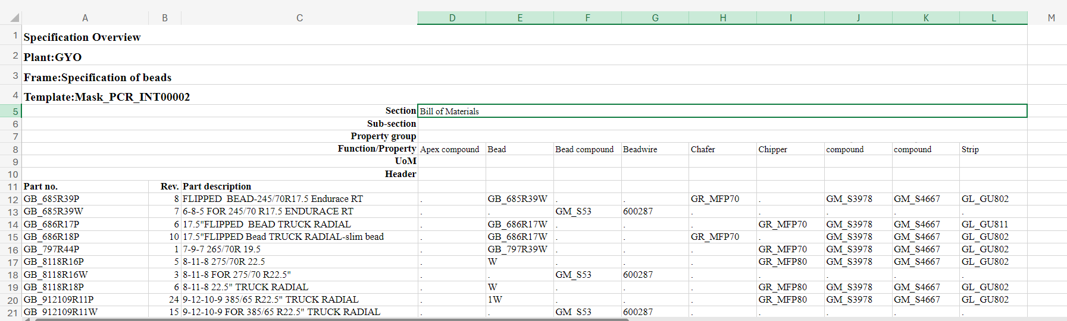

**Frame-id: A_Bead v1**

Template: Mask_PCR_INT00002

SELECT distinct template_description, template_plant, PART_PLANT

FROM sc_lims_dal.av_spec_overview_plant_frame_id a

WHERE a.part_plant = ('ENS')

and a.frame_id = ('A_Bead v1')

UNION

SELECT 'No template', null, null

order by 1

;

No template

PCR - BEAD APEXING SPECIFICATION GYO GYO

PCR - BEAD WINDING SPECIFICATION GYO GYO

TBR - BEAD APEXING SPECIFICATION GYO GYO

TBR - BEAD WINDING SPECIFICATION GYO GYO

Totaal aanwezig zonder selectie op PLANT:

A_Bead v1 27.00 Specification of beads **Mask_PCR_INT00002** PCR - BEAD WINDING SPECIFICATION GYO GYO Gyöngyöshalász

A_Bead v1 27.00 Specification of beads Mask_PCR_INT00002 PCR - BEAD WINDING SPECIFICATION DEV Development Plant

A_Bead v1 27.00 Specification of beads Mask_PCR_INT00008 TBR - BEAD WINDING SPECIFICATION GYO GYO Gyöngyöshalász

A_Bead v1 27.00 Specification of beads Mask_PCR_INT00008 TBR - BEAD WINDING SPECIFICATION DEV Development Plant

A_Bead v1 27.00 Specification of beads Mask_TBR_INT00055 TBR - BEAD APEXING SPECIFICATION GYO GYO Gyöngyöshalász

A_Bead v1 27.00 Specification of beads Mask_TBR_INT00055 TBR - BEAD APEXING SPECIFICATION DEV DEV Development Plant

A_Bead v1 27.00 Specification of beads Mask_PCR_INT00039 PCR - BEAD APEXING SPECIFICATION GYO GYO Gyöngyöshalász

A_Bead v1 27.00 Specification of beads Mask_PCR_INT00039 PCR - BEAD APEXING SPECIFICATION DEV DEV Development Plant

select * from sc_lims_dal.AV_REQOV_BASE_SELECT_SPECPROP_NW where part_no = ‘**Mask_PCR_INT00002’** ;

INCL. PROP

FRAME-ID: A_Innerliner v1 Apollo Innerliner material v1

A_Innerliner v1 23.00 Apollo Innerliner material v1 Mask_PCR_INT00044 PCR INNER LINER / SQUEEGEE SPECIFICATION GYO GYO Gyöngyöshalász

A_Innerliner v1 23.00 Apollo Innerliner material v1 Mask_TBR_INT00050 TBR - RHL EXTRUDER SPECIFICATION GYO GYO Gyöngyöshalász

Result:

Nanthakumar JJ : In my opinion, The views and structure for new Athena2.0 report is working as expected. Template/part-no **Mask_PCR_INT00002** is related to GYO as you proved in the meeting.  The only thing i cannot explain is why the current Athena-report is only showing the BOM-structure and not also the template-properties related to the selected template.

However, as you can see in View sc_lims_dal.av_spec_overview_plant_frame_id for this frame-id there are also some records from the Development-plant for which no template-plant exists. May be, those records affects the current Athena-report, i don't know. But it isn't logical, and i cannot explain why the current report is acting the way it does.

So my current conclusion will be, to develop the new Athena2.0-report the way as currently designed. In this case we are also going to show the template-properties for plant=GYO.